Quiz 1 20/2/2020

In the Hypothetical Machine the contents of memory was as shown. And PC contents is 300. Show the contents of memory and PC , AC , IR after execute three instructions (three fetch cycle and there execute cycle)

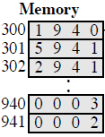

Show the contents of PC , AC and IR and memory after the execution of each instruction of the following program on the Hypothetical Machine:

300 LOAD 550

301 ADD 551

302 STORE 600

Where the contents of memory at 550 is 3 and at 551 is 4.

The following figure provide the main characteristics of Hypothetical Machine.

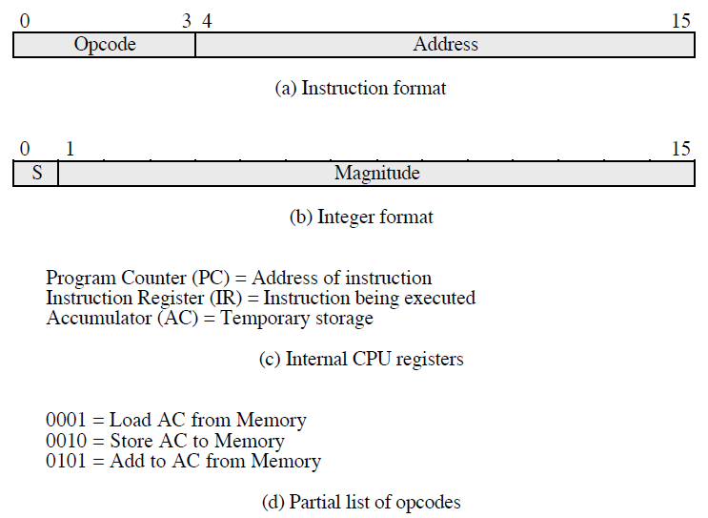

The hypothetical machine also has two I/O instructions:

0011 = load AC from I/O

0111 =store AC to I/O

In these case, the 12-bi address identifies a particular I/O device. Show the program execution for the following program:

1. Load AC from device 5.

2. Add contents of memory location 940.

3. Store AC to device 6.

Assume that the next value retrieved from device 5 is 3 and that location 940 contains a value of 2.

ANSWER

NAME : samar antar SEC : 4

**FETCH EXECUT**

|  |  |
| --- | --- |
| AC : 0000  IR : 1940 PC : 300  -------------------------------------  940 :0003  941 :0002 | AC : 0003  IR : 1940 PC : 300  -------------------------------------  940 :0003  941 :0002 |
| AC : 0003  IR : 5941 PC : 301  -------------------------------------  940 :0003  941 :0002 | AC : 0005  IR : 5941 PC : 301  -------------------------------------  940 :0003  941 :0002 |
| AC : 0005  IR : 2941 PC : 302  -------------------------------------  940 :0003  941 :0002 | AC : 0000  IR : 2941 PC : 302  -------------------------------------  940 :0003  941 :0005 |

**FETCH EXECUT**

|  |  |
| --- | --- |
| AC : 0000  IR : 1550 PC : 300  -------------------------------------  550 :0003  551 :0004  600 :0000 | AC : 0003  IR : 1550 PC : 300  -------------------------------------  550 :0003  551 :0004  600 :0000 |
| AC : 0003  IR : 5551 PC : 301  -------------------------------------  550 :0003  551 :0004  600 :0000 | AC : 0007  IR : 5551 PC : 301  -------------------------------------  550 :0003  551 :0004  600 :0000 |
| AC : 0007  IR : 2600 PC : 302  -------------------------------------  550 :0003  551 :0004  600 :0000 | AC : 0000  IR : 2600 PC : 302  -------------------------------------  550 :0003  551 :0004  600 :0007 |

|  |  |
| --- | --- |
| MEMORY | |
| 300 | 3005 |
| 301 | 5940 |
| 302 | 7006 |

**THIRD TIME :-**

**device 5 : 0003**

**940 : 2**

**device 6 : 0005**